This is a legal company from Colombia, whose main social object is buy and sell minerals for transform, benefit them, distribute them, brokers, export or consumption.

Within in this opportunity offer for sell Natural Asphalt also to be called “Asfaltita”. The Natural Asphalts are a wide range of asphalt base products found in nature. In these products we can get agglomerating for paving without distillation. Mainly fine sands impregnated for crude oil processed naturally compose it and it's used whit innovator technology of build in cold with technique quality and environmental protection. The “Asfaltita” mineral have an effect as an internal reinforcing agent, improving the stability and resistance of the mixtures, reducing its thermal susceptibility. His applications are mainly related whit his features as agglutinate and mineral replacement of coal.

USE OF “ASFALTITA”:
- Road use or road paving: Incorporation of “Asfaltita” to conventional binder asphalt, of commonly type use in mixtures hot asphalt for road paving produces significant improvements of his features. Generate a considerable increase of viscosity of binder who is modifying at high temperature without being affected his features at down temperatures. Reduces rutting

- Mineral replacement of coal for his calorific power.

- Is use as additive for:
  - Metallurgical Foundry
  - Cementing oil and gas wells
  - Manufacture of veneer sheets and plates of high resistance in civil constructions
  - Manufacture of paints, adhesives and printing inks
  - Electrical isolation; Brake tapes; Moulded battery boxes; thermoplastics

QUANTITY OF PRODUCT AVAILABLE:

The quantity offer of “Asfaltita” corresponds from 20.000 tons to 100.000 metric tons monthly. Actually we have 300.000 tons extracted and available for his immediate marketing, there are in our collection point. With reference to the continuity of available of product the mining Titles have validity for 30 years and have reserve of 18.000.000 tons that its equivalent to 100.000 tons monthly by 15 years.

Then we allow present technical product specifications:
Technical Product Specifications:

- PRODUCT DESCRIPTION: ROAD BITUMENT OR ASFALTITA
Name: | ROAD BITUMENT OR ASFALTITA
Prime Material: | PAVEMENT MATERIALS
State: | 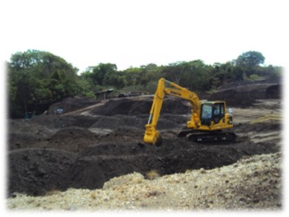  SOLID
Colour: | BLACK
Smell: | CRUDE
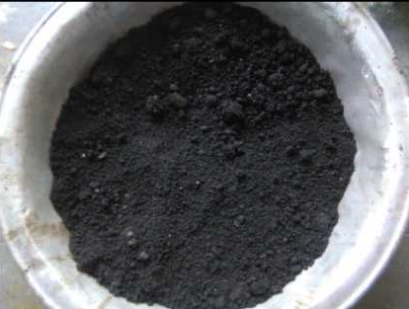  Texture: | STICKY

- SPECIFICATIONS:
ROAD BITUMEN is natural asphalt composed by fine granite materials, naturally impregnate with naturally crude oil. It is classified as material with low contends of bitumen (10-13%), which has characteristics that make it similar to asphalt 80/100 that is produced by the oil refinery.

- COMPONENTS INFORMATION:

    - Chemical Description:
ROAD BITUMENT, it is a mix of several paraffinic hydrocarbons, composed with low content of sulfur, nitrogen and oxygen; almost totally soluble in heterocyclic carbon disulfide and low content of soft hydrocarbons.

The following is the chemical composition of ROAD BITUMENT (G-089-12-1) through the team IATROSCAN –TLC/IFD – analyzer MK-6 which starts as based in liquid chromatography in a fine layer (SARA) and its compared with samples of asphalt of oil refinery 60/7 and 80/100.

Analyzed Asphalt | Fraction (%) |  |  |  | IC
 | Saturated | Aromatic | Resine | Asphalt
G-089-12-1 | 10,05 ± 0,89 | 24,52 ± 2,11 | 50,95 ± 1,08 | 14,48 ± 0,57 | 0,33
Pen 60/70 | 14,15 ± 0,89 | 59,10 ± 2,11 | 15,75 ± 1,08 | 10,98 ± 0,57 | 0,34
Pen 30/100 | 19,73 ± 0,89 | 46,71 ± 2,11 | 20,22 ± 1,08 | 13,34 ± 0,57 | 0,49

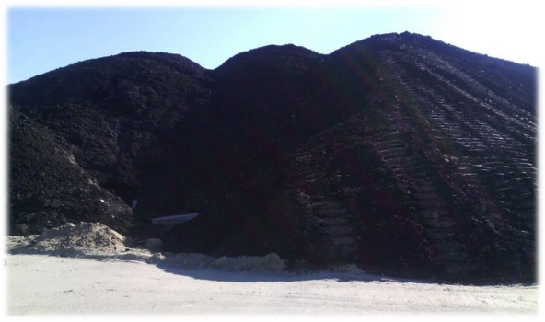

    - Dangerous components:

Identification naphtha (petroleum) or White spirit, weighted fraction hydro desulfurized with benzene <0.1% (CAS n° 64742-82-1).

Taking into account all the components of the product and its proportions, the product is considered as:
- Inflammable: Temperatures above ignition temperature 180 °C
- Irritating: Temperatures above the environment temperature, higher than 60 °C.
- Health effects: Temperatures above the environmental temperature.

The potential risks of ROAD BITUMEN is just if it is handled with temperatures higher than the environment temperature, higher than 60 °C

- PHISICAL AND CHEMICAL FEATURES OF ROAD BITUMEN:

FEATURES | VALUE | NORMS
Penetration of the asphaltic materials at 25 °C and 5 s; (0,1mm) | 83,3 | INV-E 706 (ASTM D 5)
Ductility of the asphalt materials to 25 °C, 5 cm/min; (cm) | 100+ | INV-E 702 (ASTM D 113)
Softening place of bituminous materials (ring and ball tool) (5 °C/min; (°C). | 44,9 | INV-E 712 (ASTM D 36)
Asphalt viscosity with the void capillary viscometer method to 60 °C and 300 mmHg; (Poises) | 1265,57 | INV-E 716 (ASTM D 2171)
Asphalt kinematics viscosity to 135oC; (cSt) | 224,468 | INV-E 712 (ASTM D 2170)
Water in the asphalt materials by distillation; (% Volume) | 0,19 | INV-E 704 (ASTM D 95)
Solubility of the asphalt materials in trichloroethylene; (% weight) | 99,2 | INV-E 713 (ASTM D 2042)
Index penetration of asphalt cements. | -1,4 | INV-E 724
Essay in the oven of fine asphalt layer in movement- RTOF a 163oC y 85 min; (%weight). | -6,422 | INV-E 720 (ASTM D 2872)
Penetration of the asphalt materials in 25oC, 100 g and 5 s asphalt RFTO; (0,1 MM) | 22,3 | INV-E 706 (ASTM D 5)
Residual penetration. | 27
Softening place of bituminous materials (ring tool and ball) (5 °C/min; (°C), asphalt RTFO (°C). | 57,8 | INV-E 712 (ASTM D 36)
Increase of point of softening,(°C) | 12,9

Note: As the product is a natural asphalt and we don't perform additional processes because it is offered in its natural condition, the data sheet previous could show variations of the mainly physicochemical properties according to the next ranges of variation:

FEATURES | MINIMUM VALUE | MAXIMUN VALUE
Penetration of the asphaltic materials at 25 °C and 5 s; (0,1mm) | 70 | -
Ductility of the asphalt materials to 25 °C, 5 cm/min; (cm) | 50 | -
Asphalt viscosity with the void capillary viscometer method to 60 °C and 300 mmHg; (Poises) | 700 | -
Water in the asphalt materials by distillation; (% Volume) | - | 0,35
Solubility of the asphalt materials in trichloroethylene; (% weight) | 98,5 | -

LOGISTICS
The transport of the Road Bitumen is done in trucks or tractor-trailers with capacity of 34 tonnes from their point of origin to point of discharge intro port. The Road Bitumen loose density point of origin is 1.7 t/m3 and stowage factor is 0.58 bac/mton approx.
Once the product is downloaded in port, remain in storage until complete required tons of material available for packing inside the ship, for destination of the buyer. The process of sale of Road Bitumen ends for WELT MINERAL COLOMBIA S.A.S. when the product is put in the ship in Colombian Port. The marine transport from Colombian Port to final destination port corresponds or is to charge to the buyer.

DELIVER: F.O.B. (FREE ON BOARD) in the ship bulk.

PORT OF SHIPMENT: Port located in Atlantic Ocean – Caribbean Sea, in the northern part of South America or in Pacific Ocean.

PORT OF DESTINATION: Determined by the buyer.

PRICE: The selling price is 423$USD TONS put in Colombian Port (F.O.B.)
PAYMENT: The signing of the contract the buyer will provide a credit letter at sight, irrevocable equal to 100% of the initial order, an the same process will apply for the following orders. The credit letter it will be effective for the release of the load in Colombian Port on presentations of documents and BL.
This offer is valid for 30 days.

